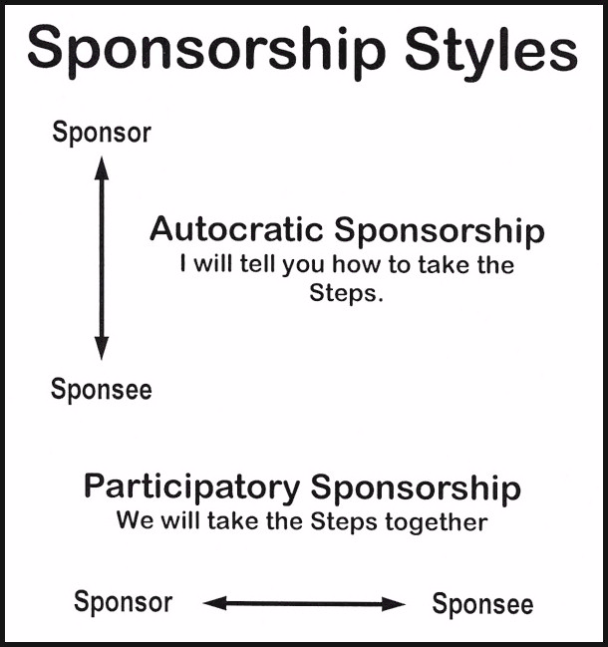

In the 1940’s, the A.A. Beginners’ Meetings ’s provided a safe and structured environment where newcomers TOOK all Twelve Steps and recovered from alcoholism, as well as a place where those who had been through the Steps learned how to sponsor those who were just starting on their spiritual journeys. The Beginners’ Meetings fos-tered participatory sponsorship and many newcomers were spon-sored by two or more A.A. members, the sponsor and his or her apprentice(s). The term the early A.A.’s used to describe this rela-tionship was co-sponsorship.

