Back to Basics-101
An introduction to the Twelve Steps of Recovery
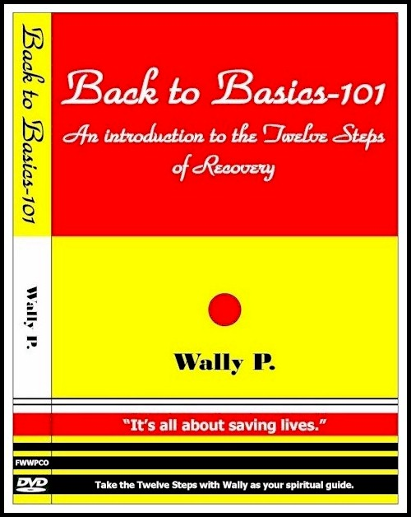
During this seventy-five minute DVD, Wally P., noted archivist, historian and author, takes you through all Twelve Steps the way they were taken during the early days of the Twelve-Step movement. Experience the miracle of recovery as Wally demonstrates the sheer simplicity and workability of the process that has saved millions of lives throughout the past seventy years.

Wally has taken more than 500,000 people through the Twelve Steps in his Back to Basics seminars. He has made this “Introduction to the Twelve-Steps” hundreds of times at treatment centers, correctional facilities and twelve-step groups throughout the world.

This is a DVD for newcomers and old-timers alike. You can watch it in its entirety, or divide it into three segments: Surrender (Steps 1, 2 and 3); Sharing and Amends (Steps 4, 5, 6, 7, 8 and 9); and Guidance (Steps 10, 11 and 12).

The accompanying CD contains twenty-four pages of PDF presentation materials for facilitators and handouts for participants. Here is everything you need to take the Steps “quickly and often.”

Wally has modified the “Big Book” passages so they are gender neutral and applicable all addictions and compulsive disorders. In keeping with the Twelve-Step community’s tradition of anonymity, he does not identify himself, or anyone else in this DVD, as a member of any Twelve-Step program.

This DVD was produced at the Arizona Public Media Studios in Tucson, AZ using high definition cameras, flat screen graphics, and PowerPoint overlays. It is a state-of-the-art production that is both instructive and enlightening.

To order this DVD plus CD, please contact:

Faith With Works Publishing Company
P. O. Box 91648 ~ Tucson, AZ 85752
520-297-9348
DVD+CD Price: $79.95 + $11.05 (priority s/h)
Total Price: $91.00

