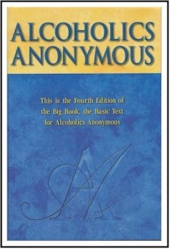
Let’s get ….

BACK TO THE

BASICS

…. of Recovery

With Wally P. (Tucson, AZ) A.A. Archivist and Historian
(Caretaker of the Dr. Bob and Anne Smith Archives)

Saturday, January 23, 2010

1:30-3:00 pm
Back to the Basics of the Big Book

During this workshop, Wally P. will take everyone in attendance through the Twelve Steps in ninety minutes, using the same “Big Book” passages used by Dr. Bob and many A.A. pioneers in the 1940’s to produce a 50-75% recovery rate.

Eagles Hall (Nick at Noon location)
4425 Burnham Drive
Gig Harbor, WA 98334

5:30-7:00 pm
Back to the Basics of Sponsorship

During this workshop, Wally P. will demonstrate, using the “Big Book,” how newcomers were sponsored through the Twelve Steps during the 1940’s. This is an event for sponsors, sponsees, and those wishing to learn more about the simple and straightforward process that was used during A.A.’s early days.

Givens Activity Center
1025 Tacoma Ave. Port Orchard, Wa 98366
Pot Luck dinner 7:00pm

For more information, please contact:
Wallace W. 206-919-2887 (both events) and
Pat H. 360-204-2096 (Port Orchard event only)
Ted P. 360-551-6880

