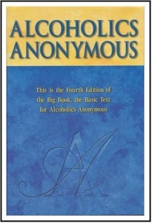
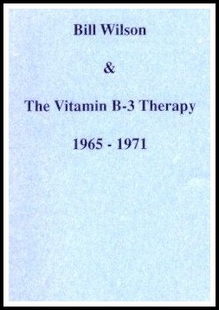
Healing the Mind, Body and Spirit

The Importance of Nutrition, Exercise and Meditation for Long-term, Contented Sobriety

With Wally P. (Tucson, AZ) Archivist, Historian and Author
Lisa S. (Portland, ME) Nutritionist and Spiritual Guide
Dr. Wayne M. (Hong Kong) Medical Director of “Recovery Works”
David Dill S. (Lyme, CT) Master Chef

Saturday and Sunday, May 22-23, 2010
(The agenda is on the reverse side of this flyer)
The Wilson House
378 Village Street ~ East Dorset, VT 05253
You have recovered from “a seemingly hopeless state of mind and body.” Now the challenge is to stay recovered.

During this seminar you will learn how A.A. pioneers and friends addressed nutrition during the early days of the fellowship and how you can minimize the potential for relapse by “kicking the sugar habit” and getting off the emotional roll-a-coaster created by eating “junk food.” In addition, the presenters will provide information on special foods and supplements for those in early recovery, the value and effect of exercise, and how meditation can rocket you into the “fourth dimension of existence.”

---------------------------------------------------------------------------------------------------

To register by mail, please complete the form below & return it with your check or money order to:
“The Wilson House” - P. O. Box 46 – Ease Dorset, VT 05253
For more information, call 802-362-5524 or visit The Wilson House website at: www.wilsonhouse.org

Number of Attendees ______ X $90.00 = ____________________

The registration fee includes: the cost of the seminar, handouts, a food/guidance journal, and all specially prepared Saturday meals and Sunday breakfast.

Name: _______________________________________________ Phone: _____________________

Address: _________________________________________________________________________

City: _____________________________________ State: ________ Zip: _____________________

