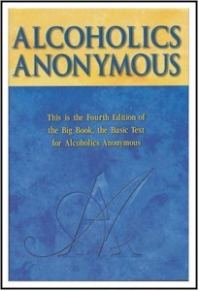
The Greatest Spiritual Movement of the Twentieth Century
Volume 2

With Wally P. (Tucson, AZ) A.A. Archivist and Historian

Friday—Sunday, Oct 30-Nov 1, 2015
(The agenda is on the reverse side of this flyer)
The Wilson House
378 Village Street
East Dorset, VT 05253

(From Bennington, VT take Hwy 7 NORTH for 26 miles. In East Dorset, VT, turn RIGHT onto MAD TOM ROAD. After 0.1 miles, the Wilson House is on the SE corner of MAD TOM ROAD and VILLAGE STREET)

This is a seminar for “anyone or everyone interested in a spiritual way of life.” This seminar is based on Wally P’s archival research from 1996 to 2015. Volume 1 was presented at the Wilson House in March 1996.

---------------------------------------------------------------------------------------------------

To register by mail, please complete the form below & return it with your check or money order to:
“The Wilson House” - P. O. Box 46 – Ease Dorset, VT 05253
For more information, call 802-362-5524 or visit The Wilson House website at: www.wilsonhouse.org

Number of Attendees ______ X $110.00 = ____________________

The registration fee includes: the cost of the seminar, handouts, all Saturday meals, and a Sunday continental breakfast

Name: __________________________________ Phone: _____________________

Address: ____________________________________________________________

City: ______________________________ State: ______ Zip: _________________

