“Big Book”
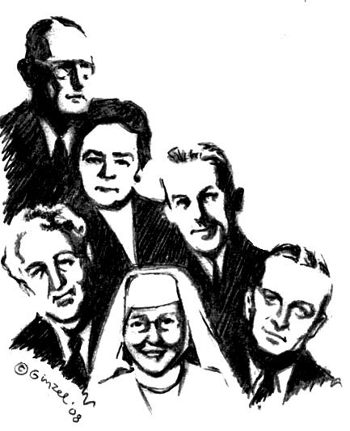
Twelve Step Workshop
We will be taking all Twelve Steps following the spiritual directions from the Big Book.

“A design for living the 12 Steps”
9 am – 5 pm
August 2, 2008
Independence Club
7024 Spring Garden Drive
Springfield, VA 22150
Bring your Big Book, a Pen, a Highlighter, a Friend, someone to share with for the day or we will provide you with someone.
Do you want to be happy, joyous, and free now or later?
Get “unstuck” on your steps ~ 4th step work-sheets plus
expand your spiritual program on the 11th Step with two-way communication with God like Dr. Bob and early A.A.’s used.

9 –9:45 am  History of the A.A. Beginners’ Meetings  and Sponsorship presentation  A.A. Archives will be displayed all day.  (Break) 9:45 - 10:00 am  10 – 11:15 am  Session # 1 Surrender ~Steps 1, 2 , and 3  (Break) 11:15 - 11:30 am  11:30 am - 12:45 pm  Session # 2 Sharing ~Steps 4 and 5.  Fourth Step will be written out during meeting | 12:45 – 2 pm: Lunch Break 1 ¼ hr  Lunch provided with “hat” passed  Do 5th Step with Sponsor or Sharing Partners  2 - 3:15 pm  Session # 3 Restitution ~Steps 6, 7, 8 ,9 and 10  (Break) 3:15-3:30 pm  3:30 pm - 4:45 pm  Session # 4 Guidance ~Steps 11 and 12  “Mother of AA” Anne Smith archives.

Please call 202 841-5906

to sign up and help us with an attendance count.

Leave your name, number and who is coming with you.

