Name: ____# of Tickets

Take all Twelve Steps in Four One-hour Sessions
With Wally P. (Tucson, AZ) A.A. Archivist, Historian and Author
This seminar is an intensive workshop, where you will TAKE all of AA's Twelve Steps in one day, the
same way the AA pioneers did! The "Back to Basics" program is modeled on the original Beginners’
Meetings that produced a substantial recovery rate from alcoholism in the 1940s.


University of North Texas Health Science Center
3500 Camp Bowie Blvd.
Fort Worth, TX 76107
(see back for map and specific room location)
The registration fee for this workshop is $25 per person, which includes admission, coffee, lunch, seminar handouts, guidance journal, and a sobriety card. Scholarships are available for those who cannot afford the registration fee. For more information on this workshop, please contact: Mac T. at (817) 613-6262 or Trish N. at (817) 602-6651.
Seating is limited. Register Early!!
To register by mail, please complete the form below
& return it with payment of $25 per person to:
Mac T ., P.O. Box 9708, Fort Worth, TX 76 147-2708
Make checks payable to: BFC
Doors open between 8am - 8:30am
Saturday, September 6, 2008
9am - 4:30pm

Betty Ford Center Alumni Chapter Presents, in Fort Worth...
Back to Basics
Address: Phone:
City: State: Zip:
Lunch included. OVER
Back to Basics Seminar
University of North Texas Health Science Center
3500 Camp Bowie Blvd., Fort Worth, TX 76107
Education & Administration (EAD) Building
(look for the Flagpole by Main Entrance)
Luibel Hall—lower level on 1st floor, Room #108

Note: Please Park in Parking Lot A
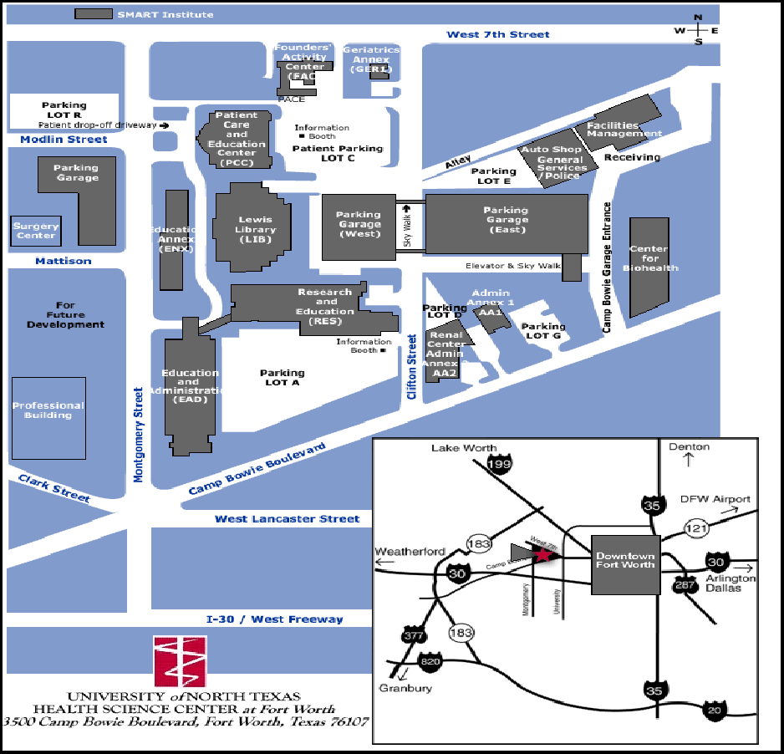

Saturday Morning: 9:00 am - 9:30 am    Overview of the Recovery Process  Saturday Morning: 9:30 am - 9:45 am    Break  Saturday Morning: 9:45 am - 10:45 am    Beginners' Meeting - Session 1~~Steps 1, 2 & 3  Saturday Morning: 10:45 am - 11:00 am    Break  Saturday Morning: 11:00 am - 12:00 noon    Beginners' Meeting - Session 2~~Steps 4 & 5 | Saturday Afternoon: 12:00 noon - 2:00 pm   Lunch Break (Food Provided by Host Committee)    5th Step with Sponsor or Sharing Partner  Saturday Afternoon: 2:00 pm - 3:00 pm   Beginners' Meeting - Session 3 ~~Steps 6, 7, 8 & 9  Saturday Afternoon: 3:00 pm - 3:30 pm   Break (Practice Eleventh Step / Write Guidance)  Saturday Afternoon: 3:30 pm - 4:30 pm   Beginners' Meeting - Session 4~~Steps 10, 11 & 12

