Back to Basics Seminar
Seton Shoal Creek Hospital
3501 Mills Avenue
Austin, TX 78731

Saturday Morning: 9:00 am - 9:30 am   Introductions and Seminar Overview  Saturday Morning: 9:30 am - 9:45 am   Break  Saturday Morning: 9:45 am - 10:45 am   Beginners' Meeting - Session 1~~Steps 1, 2 & 3  Saturday Morning: 10:45 am - 11:00 am   Break  Saturday Morning: 11:00 am - 12:00 noon   Beginners' Meeting - Session 2~~Steps 4 & 5  Saturday Afternoon: 12:00 noon - 2:00 pm   Lunch Break (Food Provided by Host Committee)   5th Step with Sponsor or Sharing Partner  Saturday Afternoon: 2:00 pm - 3:00 pm   Beginners' Meeting - Session 3 ~~Steps 6, 7, 8 & 9  Saturday Afternoon: 3:00 pm - 3:30 pm   Break (Practice Eleventh Step / Write Guidance)  Saturday Afternoon: 3:30 pm - 4:30 pm   Beginners' Meeting - Session 4~~Steps 10, 11 & 12 | 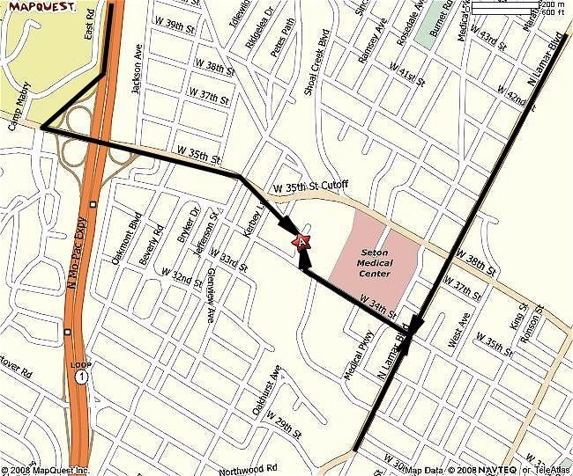

FROM THE SOUTH (SAN ANTONIO)  Take onto I-35 NORTH toward AUSTIN.  Take EXIT 235A toward 15TH/M.L.K. BLVD/ STATE CAPITOL.  After 0.2 mi, Turn SLIGHT LEFT onto I-35 N.  After < 0.1 mi, turn LEFT onto E 15TH ST.  After 1.2 mi, turn SLIGHT RIGHT onto ramp.  After 0.1 mi, keep RIGHT at the fork in the ramp.  After < 0.1 mi, merge onto N LAMAR BLVD.  After 1.9 mi, turn LEFT onto W 34TH ST.  After 0.3 mi, turn SLIGHT RIGHT onto W 35TH ST.  After 0.1 mi, end at 3501 Mills Ave Austin, TX 78731-6309 | FROM THE NORTH (DALLAS)  Take I-35EAST SOUTH toward WACO.  At the JUNCTION of I-35 EAST and I-34WEST, merge onto I-35 S/US-81 S via the exit on the LEFT.  After 120.9 mi, take the TX-45-TOLL exit, EXIT 250B, toward TX-1-TOLL.  After 0.5 mi, take the TX-45-TOLL W exit toward TX-1-TOLL S.  After 0.7 mi, merge onto TX-45 TOLL W (Portions toll).  After 0.5 mi, take the TX-1-TOLL S exit.  After 0.9 mi, merge onto TX-1 LOOP S (Mo Pac EXPRESSWAY–Portions toll).  After 12.1 mi, take the 35TH ST exit.  After 0.2 mi, take the 35TH ST EAST ramp.  After 0.2 mi, take the 35TH ST ramp.  After 0.2 mi, turn SLIGHT RIGHT onto W 35TH ST.  After 0.5 mi, turn SLIGHT RIGHT to stay on W 35TH ST.  After 0.1 mi, end at 3501 Mills Ave Austin, TX 78731-6309 | FROM THE EAST (HOUSTON)  Take US-290 WEST toward AUSTIN.  At the junction of US-290 and HWY 36, merge onto US-290 WEST toward AUSTIN.  After 82.8 mi, at the I-35 interchange, merge onto RR 2222 WEST.  After 1.7 mi, turn LEFT onto N LAMAR BLVD.  After 2.0 mi, turn RIGHT onto W 34TH ST.  After 0.3 mi, turn SLIGHT RIGHT onto W 35TH ST.  After 0.1 mi, end at 3501 Mills Ave Austin, TX 78731-6309

