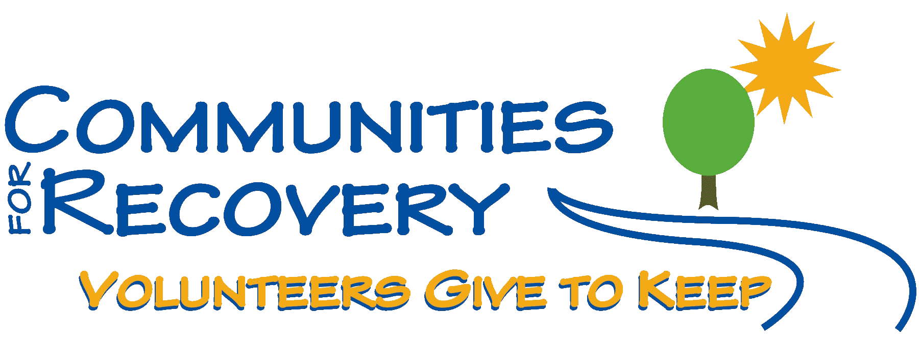
PRESENTS

Wally P
AND

The Basic Recovery Workshop
“Here are the steps we took”… (in 4 one-hour sessions)

Bring your Sponsor and Sponsees to
work the 12 Steps
Saturday, August 1, 2009
8:00 a.m. – 4:30 p.m.
Austin State Hospital – All Faith’s Chapel
4110 Guadalupe St., Austin, Texas

Wally P will be introduced by Dr. William Loving,
Medical Director of Texas Star Recovery

Sunday, August 2, 2009
10 a.m. – 11 a.m.
Guided Meditation
Austin State Hospital – All Faith’s Chapel
4110 Guadalupe St., Austin, Texas

Suggested Donation $20
Includes: Breakfast, Lunch, hand-outs, Guidance Journal

Space is limited - Pre-Registration is Required
To register Visit www.CforR.org or Call 512-615-GIVE(4483)

