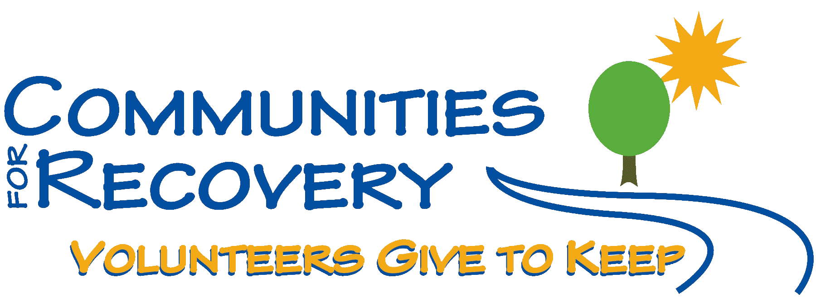

PRESENTS

Wally P.
AND
The Basic Recovery Workshop

“Here are the steps we took”… (in 4 one-hour sessions)

Bring your Sponsor and Sponsees and
TAKE all Twelve Steps

Saturday, July 10, 2010
9:00 a.m. – 4:30 p.m.

Austin State Hospital – All Faith’s Chapel
4110 Guadalupe St. – Austin, Texas 78751-4223

Sunday, July 11, 2010
10:00 – 11:00 a.m.
Eleventh Step Guidance Meeting

Austin State Hospital – All Faith’s Chapel
4110 Guadalupe St. – Austin, Texas 78751-4223

Suggested Donation: $20.00
(Scholarships are available for those who cannot afford the suggested donation)

Includes: Cost of Seminar, Lunch, hand-outs, and Guidance Journal

For more information, call 512-785-7686
or visit, www.cforr.org

