FREE “Big Book”
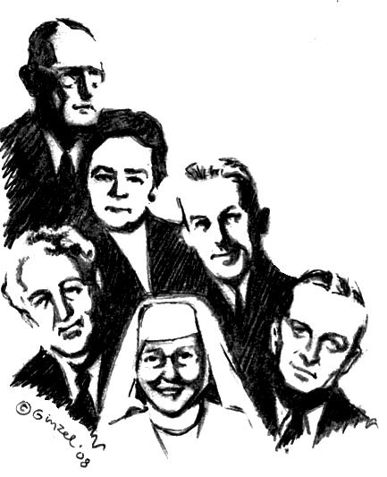
Twelve Step Workshop
We will be taking all Twelve Steps following the Spiritual directions from the Big Book.
Sponsored and hosted by District 5 area 64
“A design for living the 12 Steps”
Saturday 9:00am-5:00pm

September 6th 08
Lakota Events Hall
46954 277nd St. Tea, SD 57064

Bring your Big Book, bring a Pen, bring a Highlighter, bring a Friend. Bring someone to share with, for the day or we will provide you with someone. Do you want to be happy, joyous, and free now or later? Get “unstuck” on your steps ~ 4th step work-sheets & expand your spiritual program on the 11th Step two-way communication with God that Dr. Bob and early A.A.’s used.

9:00AM – 9:45 AM   History of the A.A. Beginners’ Meetings.  and Sponsorship presentation  A.A. Archives will be displayed all day.  (Break) 9:45am-10:00am  10:00AM – 11:15 AM   Session # 1 Surrender ~Steps 1, 2 , 3  (Break) 11:15am-11:30am  11:30AM - 12:45 PM   Session # 2 Sharing ~Steps 4 and 5.  Fourth Step will be written out during meeting | ● (Lunch Break 1 ¼ hr) 12:45PM- 2:00PM  do 5th Step with Sponsor or Sharing Partners  Lunch provided  2:00PM - 3:15PM   Session # 3 Restitution ~Steps 6, 7, 8 ,9 +10  (Break) 3:15-3:30PM  3:30PM - 4:45PM   Session # 4 Guidance ~Steps 11 + 12  “Mother of AA” Anne Smith archives presentation  during the 11th Step.

Contact: Bruce (605)-335-6224

