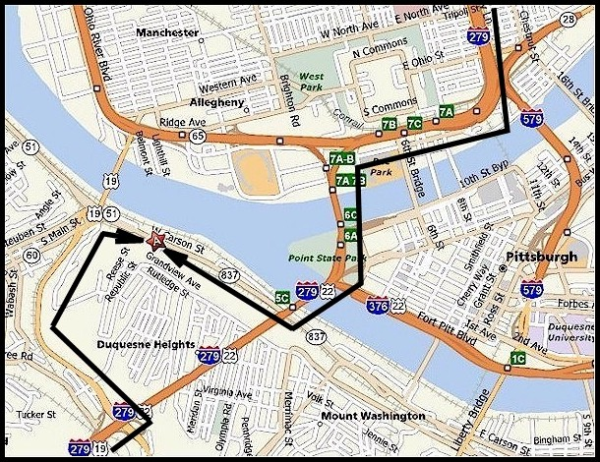
From the Northwest (Cleveland, OH)

Take I-77 S toward AKRON.

Merge onto I-80 E via EXIT 146 toward YOUNGSTOWN (Portions
toll).

After 46.3 mi, keep LEFT to take I-76 E toward PITTSBURGH
(Portions toll) (Crossing into PENNSYLVANIA).

After 51.3 mi, merge onto I-79 S via EXIT 28 toward PITTSBURGH.

After 6.9 mi, keep LEFT to take I-279 S via EXIT 72 toward
PITTSBURGH.

After 13.4 mi, Take the WEST CARSON ST/PA-837 exit, EXIT 5C,
toward PA-51/WEST END.

After 0.2 mi, turn SLIGHT RIGHT onto W CARSON ST/PA-837.

After 0.4 mi, end at 1625 W Carson St Pittsburgh, PA 15219-1039
From the West (Columbus, OH)

Take I-70 E toward WHEELING WVA.

Merge onto I-470 E via EXIT 219 toward BELLAIRE/WASHINGTON
PA (Crossing into WEST VIRGINIA).

After 10.5 mi, merge onto I-70 E (Crossing into PENNSYLVANIA).

After 26.8 mi, merge onto I-79 N via EXIT 18 toward PITTSBURGH.

After 20.7 mi, merge onto I-279 N/US-22 E/US-30 E via EXIT 59A
toward PITTSBURGH.

After 5.2 mi, merge onto US-19 N/PA-51 N via EXIT 5C toward
WEST END.

After 1.4 mi, turn RIGHT onto W CARSON ST.

After 0.2 mi, end at 1625 W Carson St Pittsburgh, PA 15219-1039
From the North (Erie, PA)

Take I-79 S

Keep LEFT to take I-279 S via EXIT 72 toward PITTSBURGH.

After 13.4 mi, take the WEST CARSON ST/PA-837 exit, EXIT 5C,
toward PA-51/WEST END.

After 0.2 mi, turn SLIGHT RIGHT onto W CARSON ST/PA-837.

After 0.4 mi, end at 1625 W Carson St Pittsburgh, PA 15219-1039
From the East (Harrisburg, PA)

Take I-76 W/PENNSYLVANIA TURNPIKE toward PITTSBURGH
(Portions toll).

Take EXIT 146 toward I-99/BEDFORD/US-220/ALTOONA/JOHNSTOWN.

After 0.3 mi, turn LEFT onto US-220 BR.

After 0.3 mi, merge onto US-220 S via the ramp on the LEFT
toward US-30/CUMBERLAND/ALTOONA.

After 2.6 mi, merge onto US-30 W toward GREENSBURG.

After 62.7 mi, stay STRAIGHT to go onto E PITTSBURGH ST.

After 1.1 mi, stay STRAIGHT to go onto E OTTERMAN ST/PA-130 W.
Continue to follow E OTTERMAN ST.

After 1.2 mi, merge onto US-30 W.

After 20.4 mi, merge onto US-22 W/US-30 W toward PITTSBURGH.

After 8.5 mi, take the WEST CARSON ST/PA-837 exit, EXIT 5C,
toward PA-51/WEST END.

After 0.2 mi, turn SLIGHT RIGHT onto W CARSON ST/PA-837.

After 0.4 mi, end at 1625 W Carson St Pittsburgh, PA 15219-1039

ONALA
1625 W Carson St
Pittsburgh, PA
15219-1038
Map and
Directions

