Knights of Columbus Hall
3300 Knorr Street (S.E. Corner of Knorr and Rowland)
Philadelphia, PA 19149-2629

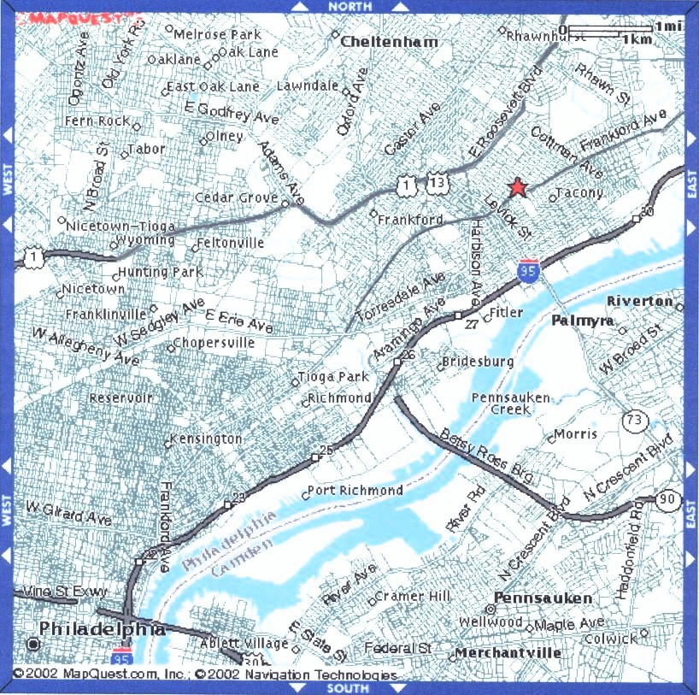

FROM the South: Take I-95 N. Take exit number 27- towards BRIDGE ST. Merge onto ARAMINGO AVE. ARAMINGO AVE becomes HARBISON AVE. Turn SLIGHT RIGHT onto FRANKFORD AVE. FRANKFORD AVE becomes FRANKFORD AVE/US-13 N. Turn SLIGHT LEFT onto ROWLAND AVE. Turn RIGHT onto KNORR ST.

FROM the North: Take I-95 S. Take the exit- exit number 30- towards PA-73/COTTMAN AVE. Stay straight to go onto WISSINOMING ST. Turn SLIGHT RIGHT onto COTTMAN AVE. COTTMAN AVE becomes COTTMAN AVE/PA-73 W. Turn LEFT onto TORRESDALE AVE/PA-73 E. Turn RIGHT onto PRINCETON AVE. Turn LEFT onto FRANKFORD AVE/US-13. Turn RIGHT onto KNORR ST.

FROM the West: Take I-76 E. Take the US-1 N exit- exit number 340B- towards ROOSEVELT BLVD. Merge onto US-1 N. Turn RIGHT onto DEVEREAUX AVE. Turn LEFT onto E ROOSEVELT BLVD. Turn RIGHT onto ROBBINS ST. ROBBINS ST becomes ROBBINS ST/US-13 N. Turn LEFT onto FRANKFORD AVE/US-13 N. Turn SLIGHT LEFT onto ROWLAND AVE. Turn RIGHT onto KNORR ST.

FROM the East: Take I-76 W. Take the I-676 N exit- exit number 2- towards CAMDEN/B FRANKLIN BR. Merge onto I-676 N. Take the I-95 exit towards TRENTON/ CHESTER. Keep LEFT at the fork in the ramp. Merge onto I-95 N. Take exit number 27- towards BRIDGE ST. Merge onto ARAMINGO AVE. ARAMINGO AVE becomes HARBISON AVE. Turn SLIGHT RIGHT onto FRANKFORD AVE. FRANKFORD AVE becomes FRANKFORD AVE/US-13 N. Turn SLIGHT LEFT onto ROWLAND AVE. Turn RIGHT onto KNORR ST.

