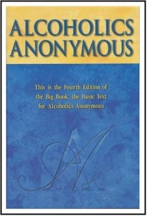
Let’s get ….

1BACK TO THE

BASICS

of sponsorship

With Wally P. (Tucson, AZ) A.A. Archivist, Historian and Author

Sunday, September 17, 2017
7:00-8:30 pm

St. Thomas of Villanova Parish
1229 E. Lancaster Ave
Rosemont, PA 19010

This is a workshop for “anyone or everyone interested in a spiritual way of life.” (All fellowships are welcome.) Both newcomers and old-timers alike will find this presentation thought provoking and enlightening. Learn how the pioneers took newcomers through the Twelve Steps in a few hours with a 50-75% success rate.

All Expenses are being covered by the Villanova Parish which include:

24+ Hand-outs, Coffee, and Snacks.

Literature will be available during the event. Cash, check or credit cards welcome.

Wally receives no income from the sale of any literature he has authored. This is his Twelfth Step
work for which he cannot be paid.

To register or to ask questions, call: Karen Farley at 610-525-4801 x 202
or email her at bizmgr@stvparish.org by Sept. 14, 2017

