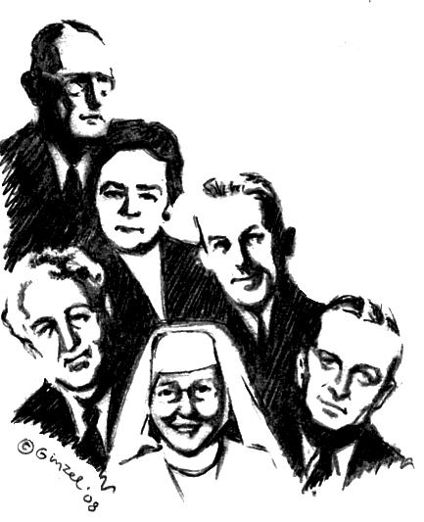
“Big Book” Workshop
We will be taking all Twelve Steps following the Spiritual directions from the Big Book.
“A design for living the 12 Steps”
2 days: Sat. Aug 9th &
Sun. Aug 10th

2607 E. Cumberland
Philadelphia, PA 19125
Bring your Big Book, bring a Pen, bring a Highlighter, bring a Friend. Bring someone to share with, for the day or we will provide you with someone. Do you want to be happy, joyous, and free now or later? Get “unstuck” on your steps ~ 4th step work-sheets & expand your spiritual program on the 11th Step two-way communication with God that Dr. Bob and early A.A.’s used.

Saturday Aug 9th  A.A. Archives will be displayed all day.  10:00AM – 11:00 AM   History of the A.A. Beginners’ Meetings.  and Sponsorship presentation  (Break) 11:00am-11:15am  11:15AM – 12:30 PM   Session # 1 Surrender ~Steps 1, 2 , 3  (Lunch Break) 12:30pm-1:00pm  1:00PM - 2:30 PM   Session # 2 Sharing ~Steps 4 and 5.  Fourth Step will be written out during meeting.  Complete Step 5 overnight. | Sunday Aug 10th  A.A. Archives will be displayed all day.  10:00AM - 11:15AM   Session # 3 Restitution ~Steps 6, 7, 8 ,9 +10  (Break) 11:15-11:30AM  11:30AM - 1:00PM   Session # 4 Guidance ~Steps 11 + 12  “Mother of AA” Anne Smith archives.  11th Step Guidance meeting.  Closing remarks.

To sign up call Peter P. 267-974-7577

