Back to Basics ~ St. Luke’s Church
5235 South Avenue ~ Youngstown, OH 44512
Nov 13, 2010

Saturday Morning: 9:00 am - 9:30 am   Introductions and Seminar Overview  Saturday Morning: 9:30 am - 9:45 am   Break  Saturday Morning: 9:45 am - 10:45 am   Beginners' Meeting - Session 1~~Steps 1, 2 & 3  Saturday Morning: 10:45 am - 11:00 am   Break  Saturday Morning: 11:00 am - 12:15 pm   Beginners' Meeting - Session 2~~Steps 4 & 5  Saturday Afternoon: 12:15 pm - 2:15 pm   Lunch Break (Food Provided by Host Committee)   5th Step with Sponsor or Sharing Partner  Saturday Afternoon: 2:15 pm - 3:15 pm   Beginners' Meeting - Session 3 ~~Steps 6, 7, 8 & 9  Saturday Afternoon: 3:15 pm - 3:30 pm   Break  Saturday Afternoon: 3:30 pm - 4:30 pm   Beginners' Meeting - Session 4~~Steps 10, 11 & 12 | 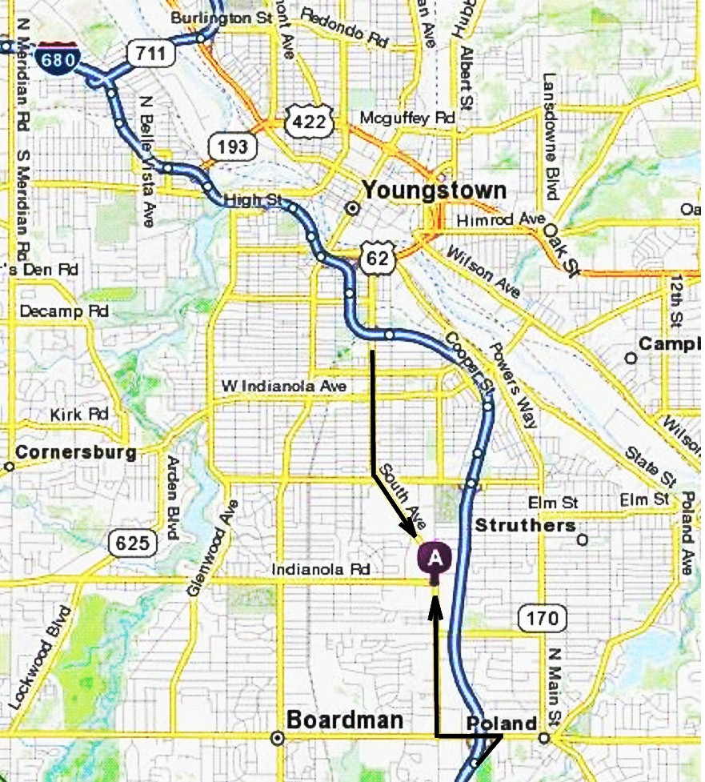

From Northwest (Cleveland, OH)  Take I-77 S toward AKRON.  After approx 16 miles, merge onto I-80 E via EXIT 146 toward YOUNGSTOWN (Portions toll).  After 46.3 miles, merge onto I-80 E via EXIT 218 toward YOUNGSTOWN  After 5.7 miles, merge onto I-680 S via EXIT 224B toward YOUNGSTOWN  After 7.0 miles, take the SOUTH AVE exit, EXIT 7.  After 0.1 miles, turn RIGHT onto SOUTH AVE.  After 2.6 miles, 5235 SOUTH AVE is on the LEFT. | From Northeast (Erie, PA)  Take I-90 W toward CLEVELAND (Crossing into OHIO).  After approx 37 miles, merge onto OH-11 S via EXIT 228 toward YOUNGSTOWN/JEFFERSON  After 49.0 miles, merge onto OH-711 S via the exit on the LEFT toward YOUNGSTOWN  After 3.4 miles, take I-680 S.  After 3.9 miles, take the SOUTH AVE exit, EXIT 7.  After 0.1 miles, turn RIGHT onto SOUTH AVE.  After 2.6 miles, 5235 SOUTH AVE is on the LEFT.
From Southwest (Columbus, OH)  Take I71 N toward CLEVELAND.  After approx 100 miles, merge onto I76 E via EXIT 209A.  After 60.2 miles, take I-80 E toward NEW YORK CITY/YOUNGSTOWN.  After 4.4 miles, merge onto I-680 S via EXIT 224B toward YOUNGSTOWN.  After 7.0 miles, take the SOUTH AVE exit, EXIT 7.  After 0.1 miles, turn RIGHT onto SOUTH AVE.  After 2.6 miles, 5235 SOUTH AVE is on the LEFT. | From Southeast (Pittsburgh, PA)  Take I-279 N.  After approx 12 miles, I-279 N becomes I-79 N.  After 5.8 miles, merge onto I-76 W via EXIT 77 toward YOUNGSTOWN OH/EXIT 13-2 (Portions toll) (Crossing into OHIO).  After 36.3 miles, merge onto I-680 N via EXIT 234 (Portions toll).  After 4.8 miles, take the US-224 exit, EXIT 11, toward CANFIELD/POLAND.  After 0.3 miles, turn LEFT onto US-224/BOARDMAN POLAND RD.

