Back to Basics ~ Eagles Lodge Fellowship Hall
1601 E. Washington Ave ~ Las Vegas, NV 89101
Jan 15, 2011

Saturday Morning: 9:00 am - 9:30 am   Introductions and Seminar Overview  Saturday Morning: 9:30 am - 9:45 am   Break  Saturday Morning: 9:45 am - 10:45 am   Beginners' Meeting - Session 1~~Steps 1, 2 & 3  Saturday Morning: 10:45 am - 11:00 am   Break  Saturday Morning: 11:00 am - 12:15 pm   Beginners' Meeting - Session 2~~Steps 4 & 5  Saturday Afternoon: 12:15 pm - 2:15 pm   Lunch Break (Food Provided by Host Committee)   5th Step with Sponsor or Sharing Partner  Saturday Afternoon: 2:15 pm - 3:15 pm   Beginners' Meeting - Session 3 ~~Steps 6, 7, 8 & 9  Saturday Afternoon: 3:15 pm - 3:30 pm   Break  Saturday Afternoon: 3:30 pm - 4:30 pm   Beginners' Meeting - Session 4~~Steps 10, 11 & 12 | 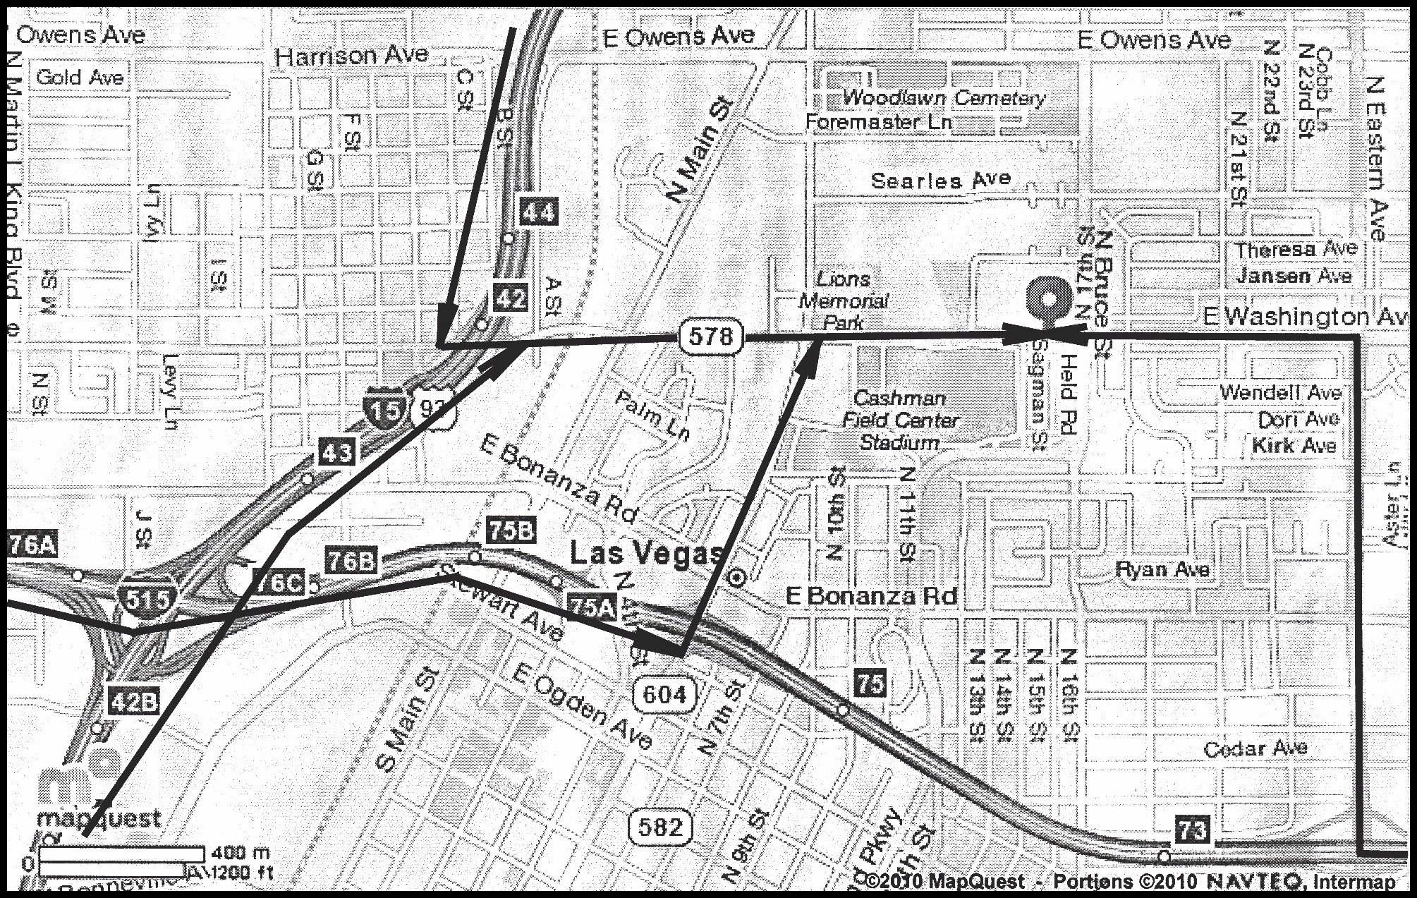

From the Northwest (Indian Springs, NV)  Take US-95 S toward LAS VEGAS  After 44.5 miles, take the LAS VEGAS BLVD. exit, EXIT 75A, toward CASHMAN CENTER.  After 0.3 miles, turn LEFT onto N LAS VEGAS BLVD/NV-604.  After 0.6 miles, turn RIGHT onto E WASHINGTON AVE.  After 0.5 miles, make a U-TURN at N BRUCE ST onto E WASHINGTON AVE.  After 0.07 miles, 1601 E WASHINGTON AVE is on the RIGHT. | From the Northeast (St. George, UT)  Take I-15 S toward LAS VEGAS (Passing through ARIZONA, then crossing into NEVADA).  After 115.8 miles, take the WASHINGTON AVE exit, EXIT 44.  After 0.2 miles, turn SHARP LEFT onto NV-578/W WASHINGTON AVE. Continue to follow W WASHINGTON AVE.  After 1.2 miles, make a U-TURN at N BRUCE ST onto E WASHINGTON AVE.  After 0.07 miles, 1601 E WASHINGTON AVE is on the RIGHT.
From Southwest (Los Angeles, CA)  Take I-10 E. toward SAN BERNADINO.  Merge onto I-15 N toward BARSTOW (Crossing into NEVADA).  After 222.9 miles, take the D STREET exit, EXIT 43.  After 0.2 miles, keep LEFT at the fork.  After 0.2 miles, turn RIGHT onto NV-578/W WASHINGTON AVE. Continue to follow W WASHINGTON AVE.  After 1.1 miles, make a U-TURN at N BRUCE ST onto E WASHINGTON AVE.  After 0.07 miles, 1601 E WASHINGTON AVE is on the RIGHT. | From Southeast (Phoenix, AZ)  Take US-60 W toward WICKENBURG, AZ  In WICKENBURG, AZ, enter roundabout and take 1st exit onto US-93 N. Pass through one roundabout on US-93 N.  After 107.2 miles, merge onto I-40 W/PURPLE HEART TRL/US-93 N.  After 22.3 miles, take the US-93/BEALE ST exit, EXIT 48, toward AZ-68/LAS VEGAS.  After 0.3 miles, turn SLIGHT RIGHT toward AZ-68 W/BULLHEAD CITY/LAUGHLIN.  After 0.03 miles, take US-93 N (Crossing into NEVADA).  After 102.0 miles, take the EASTERN AVENUE exit, EXIT 73.  After 0.3 miles, turn RIGHT onto N EASTERN AVE.  After 0.9 miles, turn LEFT onto E WASHINGTON AVE.  After 0.6 miles, 1601 E WASHINGTON AVE is on the RIGHT.

