The Rainbow Big Book Group

OF
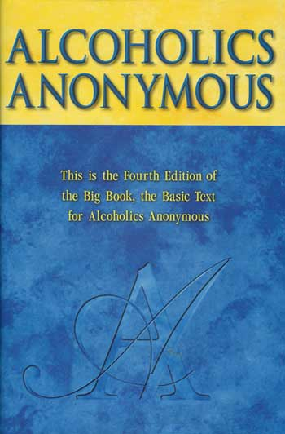
The only requirement for membership is a desire to stop drinking!!

Our Primary purpose is to stay sober and help other alcoholics to achieve sobriety!!

Come join us in the Fellowship!!

Presents:
Wally P. ~ A.A. Archivist and Historian

(At our normally scheduled A.A. meeting)
On:

Friday, October 3rd 2008
7pm – 8:30pm

At:
The First United Methodist Church
961 Valley Street
Manchester, NH 03103

