Please join us in welcoming:

Wally P. (Tucson, AZ)
A.A. Archivist and Historian

For a full day on Saturday, October 4, 2008
Back to
Basics
A.A.
Seminar
Take all 12 Steps in one day with the simple method used in the 1940’s to introduce newcomers to the A.A. program – a time when the recovery rate for Alcoholics Anonymous was 50—75%.

East Derry Congregational Church
47 East Derry Road, Derry, NH 03038
8:30 AM to 4:00 PM

Admission $10
Admission covers the cost of the facility, the seminar, handouts, coffee,
tea, continental breakfast, lunch, guidance journal and sobriety card.

Scholarships are available for those in halfway homes, treatment facilities or otherwise unable to afford the cost of admission.
Purchase tickets early, as seating is limited.
For additional information, call Scott G (603) 924-0939.
Tickets by mail: Send self-addressed stamped envelope & check payable to:
“Back to Basics”, 28 Birch Drive, Peterborough, NH 03458
Back To Basics One
Day A.A. Seminar

Provided for you: Coffee, tea, water and snacks, lunch, Back to Basics handout materials, guidance book and sobriety card.
Saturday October 4, 2008
8:30 AM to 4:00 PM
East Derry Congregational Church
47 East Derry Road, Derry, NH 03038

Please bring: “Big Book” and paper/pen
Agenda
Continental Breakfast 8:30 AM
Opening and Introductions Planning Committee 9:00 AM
Session I: Steps 1, 2, and 3 Wally P 9:15 AM
Break 10:15 AM
Session II: Step 4 Wally P 10:30 AM
Step 5 with Sharing Partner and Lunch Lunch will be provided 11:30 AM
Session III: Steps 6, 7, 8, and 9 Wally P 1:30 PM
Meditation and Quiet Time All 2:30 PM
Session IV: Steps 10, 11, and 12 Wally P 3:00 PM
Closing and Exit Planning Committee 4:00 PM
Directions
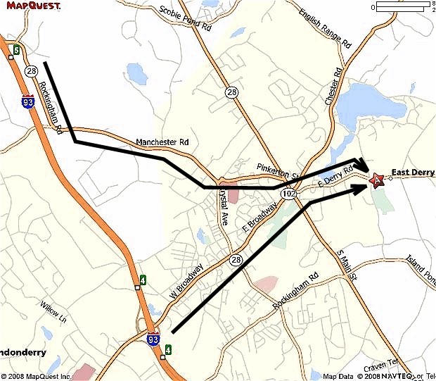 | FROM THE NORTHWEST  Take I-93 S (Portions toll) toward MASSACHUSETTS  Take the RT-28 S exit, EXIT 5, toward DERRY.  After 0.1 mi, turn LEFT onto NH-28/ROCKINGHAM RD. Continue to follow NH-28.  After 3.2 mi, turn LEFT onto PINKERTON ST.  After 0.7 mi, turn RIGHT onto BYPASS 28/N MAIN ST/NH-28/LONDONDERRY TURNPIKE.  After 0.2 mi, enter next roundabout and take 3rd exit onto E DERRY RD.  After 1.0 mi, end at 47 E Derry Rd Derry, NH 03038-1651
FROM THE SOUTHEAST

Take I-93 N toward CONCORD, NH.

On I-93, cross into NEW HAMPSHIRE.

Take the RT-102 E exit, EXIT 4, toward DERRY.

After 0.4 mi, turn SLIGHT RIGHT onto NH-102/NASHUA RD. Continue to follow NH-102.

After 2.0 mi, enter next roundabout and take 2nd exit onto E DERRY RD.

After 1.0 mi, end at 47 E Derry Rd Derry, NH 03038-1651

