Dawn Farm ~~ 6633 Stony Creek Road ~~ Ypsilanti, MI 48197-6609

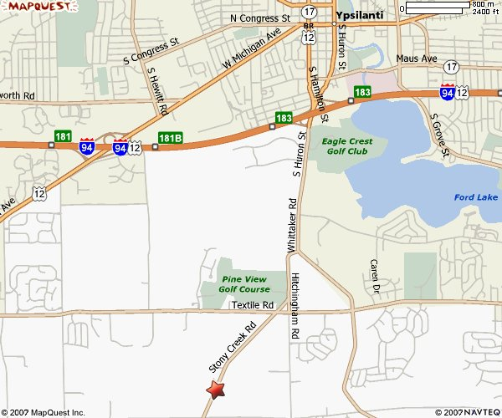
From the East

Take I-94W to the HURON ST exit--EXIT 183--toward YPSILANTI.

Turn LEFT onto US-12 BR W / S HAMILTON ST. Continue to follow US-12 BR W.

After 0.3 miles, US-12 BR W becomes S HURON ST.

After 0.8 miles, S HURON ST becomes WHITTAKER RD.

After 0.3 miles, turn RIGHT onto STONY CREEK RD.

After 0.5 miles, turn RIGHT to stay on STONY CREEK RD.

After 1.0 miles, end at 6633 Stony Creek Road
From the West

Take I-94E to the HURON ST exit--EXIT 183--toward YPSILANTI.

Turn RIGHT onto S HURON ST.

After 0.8 miles, S HURON ST becomes WHITTAKER RD.

After 0.3 miles, turn RIGHT onto STONY CREEK RD.

After 0.5 miles, turn RIGHT to stay on STONY CREEK RD.

After 1.0 miles, end at 6633 Stony Creek Road

