1Back to the Basics of Sponsorship

Sparrow Hospital Auditorium
1215 East Michigan Ave. ~ Lansing, MI 48912

Saturday’s Agenda in Detail

Saturday Morning: 09:30 am - 10:15 am   Introduction  Saturday Morning: 10:15 am – 10:30 am   Break  Saturday Morning: 10:30 am – 11:15 am   The History of Sponsorship  Saturday Morning: 11:15 noon – 11:30 am   Break  Saturday Morning: 11:30 am – 12:45 pm   Steps 1, 2, 3, and Set-up Steps 4 and 5  Saturday Afternoon: 12:45 pm – 02:30 pm   Lunch   Take Steps 4 and 5 with Sharing Partner  Saturday Afternoon: 02:30 pm – 03:15 pm   Take Steps 6, 7, 8, 9, 10, and Set-up Step 11  Saturday Afternoon: 03:15 pm - 03:30 pm   Break  Saturday Afternoon: 03:30 pm - 04:15 pm   Take Steps 11 and 12  Saturday Afternoon: 04:15 pm - 04:30 pm   Break  Saturday Afternoon: 04:30 pm - 05:00 pm   Q & A: Taking 12 Steps in 3 to 4 Hours | 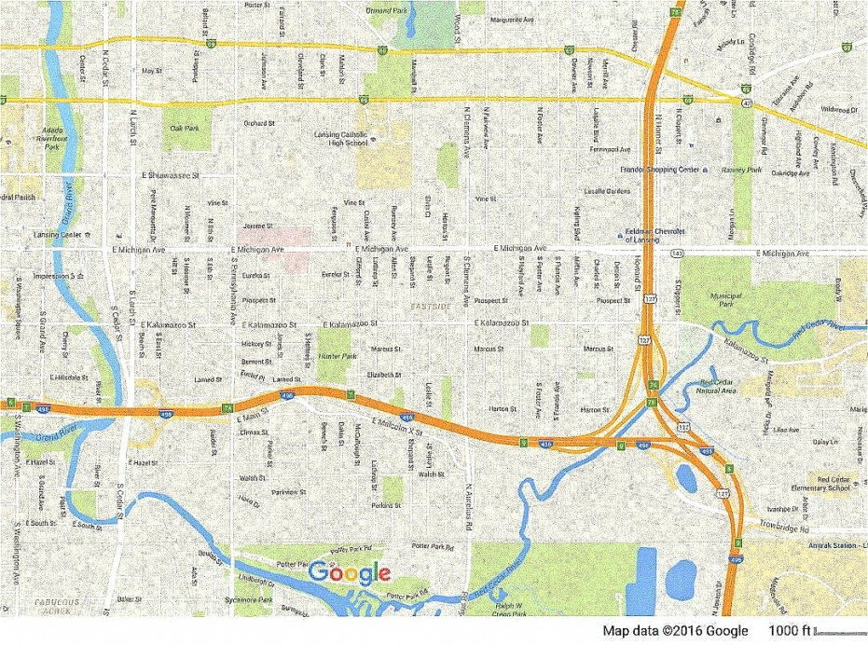  To purchase tickets or obtain more  Hospital  Parking  information please visit:  www.BackToBasicsLansing.com
From the West (Grand Rapids area)  Merge onto I-96 E.  After approximately 57 miles, merge onto I-496 E via EXIT 95 toward Downtown/Lansing.  After 7.09 miles, take EXIT 7 toward Pennsylvania Ave.  After 0.56 miles, merge onto E Malcolm X St.  After 0.14 miles, take the 1st left onto S Pennsylvania Ave.  After 0.58 miles, turn right onto E Michigan Ave.  (E Michigan Ave is just past Eureka St)  After 0.16 miles, 1215 E MICHIGAN AVE is on the left.  (The parking lot is on the right. Walk across the street or take the skybridge to the hospital. Take elevator to lower level.) | From the Southeast (Detroit area)  Take either I-96 W, or I-275 N or I-696 W until you reach the interchange  Merge onto I-96 W toward Lansing.  After approximately 57 miles, merge onto I-496 W via EXIT 106B toward Downtown Lansing.  After 4.82 miles, take the Pennsylvania Ave exit, EXIT 7, toward Larch St-Cedar St.  After 0.47 miles, turn right onto S Pennsylvania Ave.  After 0.51 miles, turn right onto E Michigan Ave.  (E Michigan Ave is just past Eureka St)  After 0.16 miles, 1215 E MICHIGAN AVE is on the left.  (The parking lot is on the right. Walk across the street or take the skybridge to the hospital. Take elevator to lower level.) | 1From the Northeast (Flint, MI area)  Merge onto I-69 W.  After approx. 41 miles, merge onto I-69 Bus W via EXIT 94 toward E Lansing.  After 7.00 miles, turn left onto N Howard Ave.  (N Howard Ave is just past N Homer St)  After 0.12 miles, stay straight to go onto N Howard St.  After 0.50 miles, turn right onto E Michigan Ave.  (E Michigan Ave is 0.1 miles past Vine St)  After 1.21 miles, 1215 E MICHIGAN AVE is on the right.  The parking lot is on the left. Walk across the street or take the skybridge to the hospital. Take elevator to lower level.)

