Back to the Basics of Sponsorship

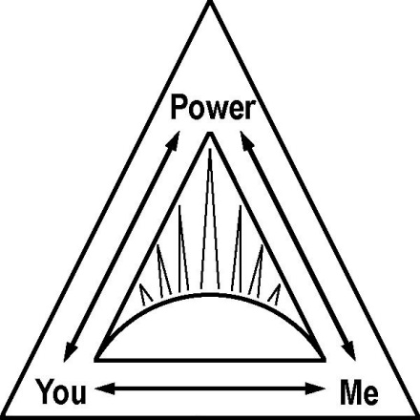

(How to sponsor or be sponsored through the 12 Steps in 2 to 3 hours)

With Wally P. (Tucson, AZ) Archivist, Historian and Author

October 20-22, 2017

Sparrow Hospital Auditorium
1215 East Michigan Ave. ~ Lansing, MI 48912
This workshop is for those in recovery, those who work with those in recovery, and those who would like to learn more about the process that produced a 50-75% recovery rate during the “early days.”

Friday, October 20: 7:00 pm - 9:00 pm

PowerPoint Presentation: “Unsung Heroes-Anne Smith and Lois Wilson”

Saturday, October 21: 9:30 am – 5:00 pm

This is a seminar for “anyone or everyone interested in a spiritual way of life.” All will find this PowerPoint presentation thought-provoking and enlightening. Everyone within or supportive of the 12-Step community is welcome.

Sunday, October: 10:00 am - 12:00 pm

PowerPoint Presentation: “The History and Evolution of Step 11” plus a reenactment of Dr. Bob and Anne Smith’s 11th Step guidance meetings. This is the most powerful meeting format in recovery. Check it out for yourself.

Tickets are $25 per seat, there is a limited time discount applicable when seating is purchased in increments of two ($45) and three ($55). Scholarship are available upon request to those who qualify.

---------------------------------------------------------------------------------------------------

To purchase tickets and obtain more information please visit:
www.BackToBasicsLansing.com

