Directions to Back to Basics Seminar
F. Scott Fitzgerald Theater—Social Hall
603 Edmonston Drive ~~ Rockville, MD 20851-1012

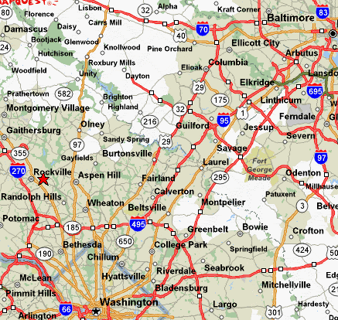 | 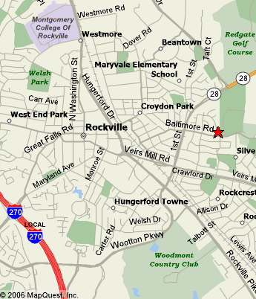
From the North:

Take I-95 S toward WASHINGTON. Merge onto I-495 W / CAPITAL BELTWAY via EXIT 27 toward SILVER SPRING. After 9.6 miles, merge onto ROCKVILLE PIKE / MD-355 N via EXIT 34 toward ROCKVILLE / BETHESDA. After 4.8 miles, turn RIGHT onto 1ST ST / MD-911 E. Continue to follow 1ST ST. After 0.5 miles, turn RIGHT onto BALTIMORE RD. After 0.3 miles, turn LEFT onto EDMONSTON DR. After <0.1 miles, end at 603 Edmonston Dr. Follow the signs to the Social Hall parking lot

From the South:

Take I-495 N / CAPITAL BELTWAY toward MARYLAND (Cross into MARYLAND). Keep LEFT to take I-270 SPUR N via EXIT 38 toward ROCKVILLE / FREDERICK. After 2.0 miles, the I-270 SPUR N becomes I-270 N. After 0.8 miles, keep RIGHT to take I-270 LOCAL N toward MONTROSE RD. After 1.7 miles, take the MD-189 exit- EXIT 5- toward FALLS RD. After <0.1 miles, merge onto GREAT FALLS RD / MD-189 N toward FALLS ROAD NORTH / ROCKVILLE / TOWN CTR. After 0.1 miles, turn LEFT onto GREAT FALLS RD / MD-189. After 0.6 miles, turn RIGHT onto W JEFFERSON ST / MD-28. Continue to follow MD-28. After 1.0 miles, turn LEFT onto 1ST ST / MD-28 E. After 0.3 miles, turn RIGHT onto BALTIMORE RD. 0.3 miles, Turn LEFT onto EDMONSTON DR. After <0.1 miles, end at 603 Edmonston Dr. Follow the signs to the Social Hall parking lot

