“Big Book”
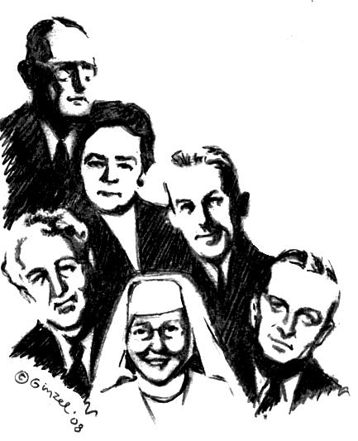
Twelve Step Workshop
We will be taking all Twelve Steps following the spiritual directions from the Big Book.

“A design for living the 12 Steps”

Sat. August 30, 2008
9 am – 5 pm
The Gift of God
660 N. 5th Ave.
Kankakee, IL 60901
Bring your Big Book, a Pen, a Highlighter, a Friend, someone to share with for the day or we will provide you with someone.
Do you want to be happy, joyous, and free now or later?
Get “unstuck” on your steps ~ 4th step work-sheets plus
expand your spiritual program on the 11th Step with two-way communication with God like Dr. Bob and early A.A.’s used.

9 –9:45 am  History of the A.A. Beginners’ Meetings  and Sponsorship presentation  A.A. Archives will be displayed all day.  (Break) 9:45 - 10:00 am  10 – 11:15 am  Session # 1 Surrender ~Steps 1, 2 , and 3  (Break) 11:15 - 11:30 am  11:30 am - 12:45 pm  Session # 2 Sharing ~Steps 4 and 5.  Fourth Step will be written out during meeting | 12:45 – 2 pm: Lunch Break 1 ¼ hr  Lunch provided with “hat” passed  Do 5th Step with Sponsor or Sharing Partners  2 - 3:15 pm  Session # 3 Restitution ~Steps 6, 7, 8 ,9 and 10  (Break) 3:15-3:30 pm  3:30 pm - 4:45 pm  Session # 4 Guidance ~Steps 11 and 12  “Mother of AA” Anne Smith archives.
To sign up please call Fred
815-295-2386

