Back to Basics Seminar
The Schnebly Recreation Hall
1101 North Atlantic Avenue
Daytona Beach, FL 32118-3628
Saturday Morning: 9:00 am - 10:30 am   Overview of the Recovery Process   Beginners' Meeting - Session 1~~Steps 1, 2 & 3  Saturday Morning: 10:30 am - 11:00 am   Break  Saturday Morning: 11:00 am - 12:00 noon   Beginners' Meeting - Session 2~~Steps 4 & 5  Saturday Afternoon: 12:00 noon - 2:00 pm   Lunch Break (Food Provided by Host Committee)   5th Step with Sponsor or Sharing Partner  Saturday Afternoon: 2:00 pm - 3:00 pm   Beginners' Meeting - Session 3 ~~Steps 6, 7, 8 & 9  Saturday Afternoon: 3:00 pm - 3:30 pm   Break (Practice Eleventh Step / Write Guidance)  Saturday Afternoon: 3:30 pm - 4:30 pm   Beginners' Meeting - Session 4~~Steps 10, 11 & 12 | 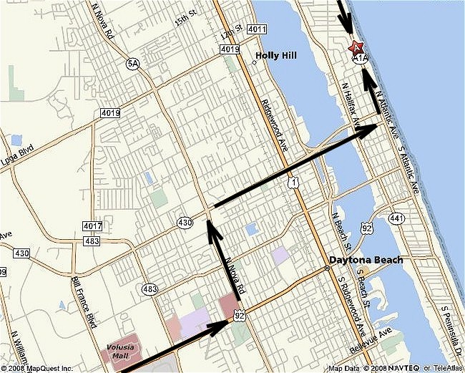

From the North  Take I-95 SOUTH toward DAYTONA  BEACH.  Take the US-1 exit, EXIT 273, toward  ORMOND BEACH/BUNNELL.  After 0.2 miles, turn SLIGHT LEFT to take the ramp toward ORMOND BEACH/HOLLY HILL/DAYTONA BEACH.  After less than 0.1 miles, turn LEFT onto  US-1 SOUTH/FL-5 SOUTH.  After 5.7 miles, turn SHARP LEFT onto  FL-40 E/W GRANADA BLVD. Continue to  follow FL-40 EAST.  After 1.5 miles, turn RIGHT onto SOUTH  ATLANTIC AVE/FL-A1A SOUTH.  After 3.5 miles, end at 1101 N Atlantic  Ave Daytona Beach, FL 32118-3628 | From the Southwest  Take I-4 EAST toward DAYTONA BEACH.  Merge onto I-95 N via the exit on the  LEFT toward JACKSONVILLE.  After 1.3 miles, take the US-92 exit,  EXIT 261, toward DELAND/DAYTONA  BEACH.  After 0.3 miles, merge onto W INTERNA-  TIONAL SPEEDWAY BLVD/US-92 EAST  toward DAYTONA BEACH/AIRPORT.  After 3.6 miles, turn LEFT onto NORTH  NOVA RD/FL-5A NORTH.  After 1.2 miles, turn RIGHT onto MASON  AVE/FL-430 EAST. Continue to follow FL-  430 EAST.  After 2.4 miles, turn LEFT onto N ATLAN-  TIC AVE/FL-A1A.  After 0.9 miles, end at 1101 N Atlantic  Ave Daytona Beach, FL 32118-3628 | From the South  Take I-95 NORTH toward DAYTONA  BEACH.  Take the US-92 exit, EXIT 261, toward  DELAND/DAYTONA BEACH.  After 0.3 miles, merge onto W INTERNA-  TIONAL SPEEDWAY BLVD/US-92 EAST  toward DAYTONA BEACH/AIRPORT.  After 3.6 miles, turn LEFT onto NORTH  NOVA RD/FL-5A NORTH.  After 1.2 miles, turn RIGHT onto MASON  AVE/FL-430 EAST. Continue to follow FL-  430 EAST.  After 2.4 miles, turn LEFT onto N ATLAN-  TIC AVE/FL-A1A.  After 0.9 miles, end at 1101 N Atlantic  Ave Daytona Beach, FL 32118-3628

