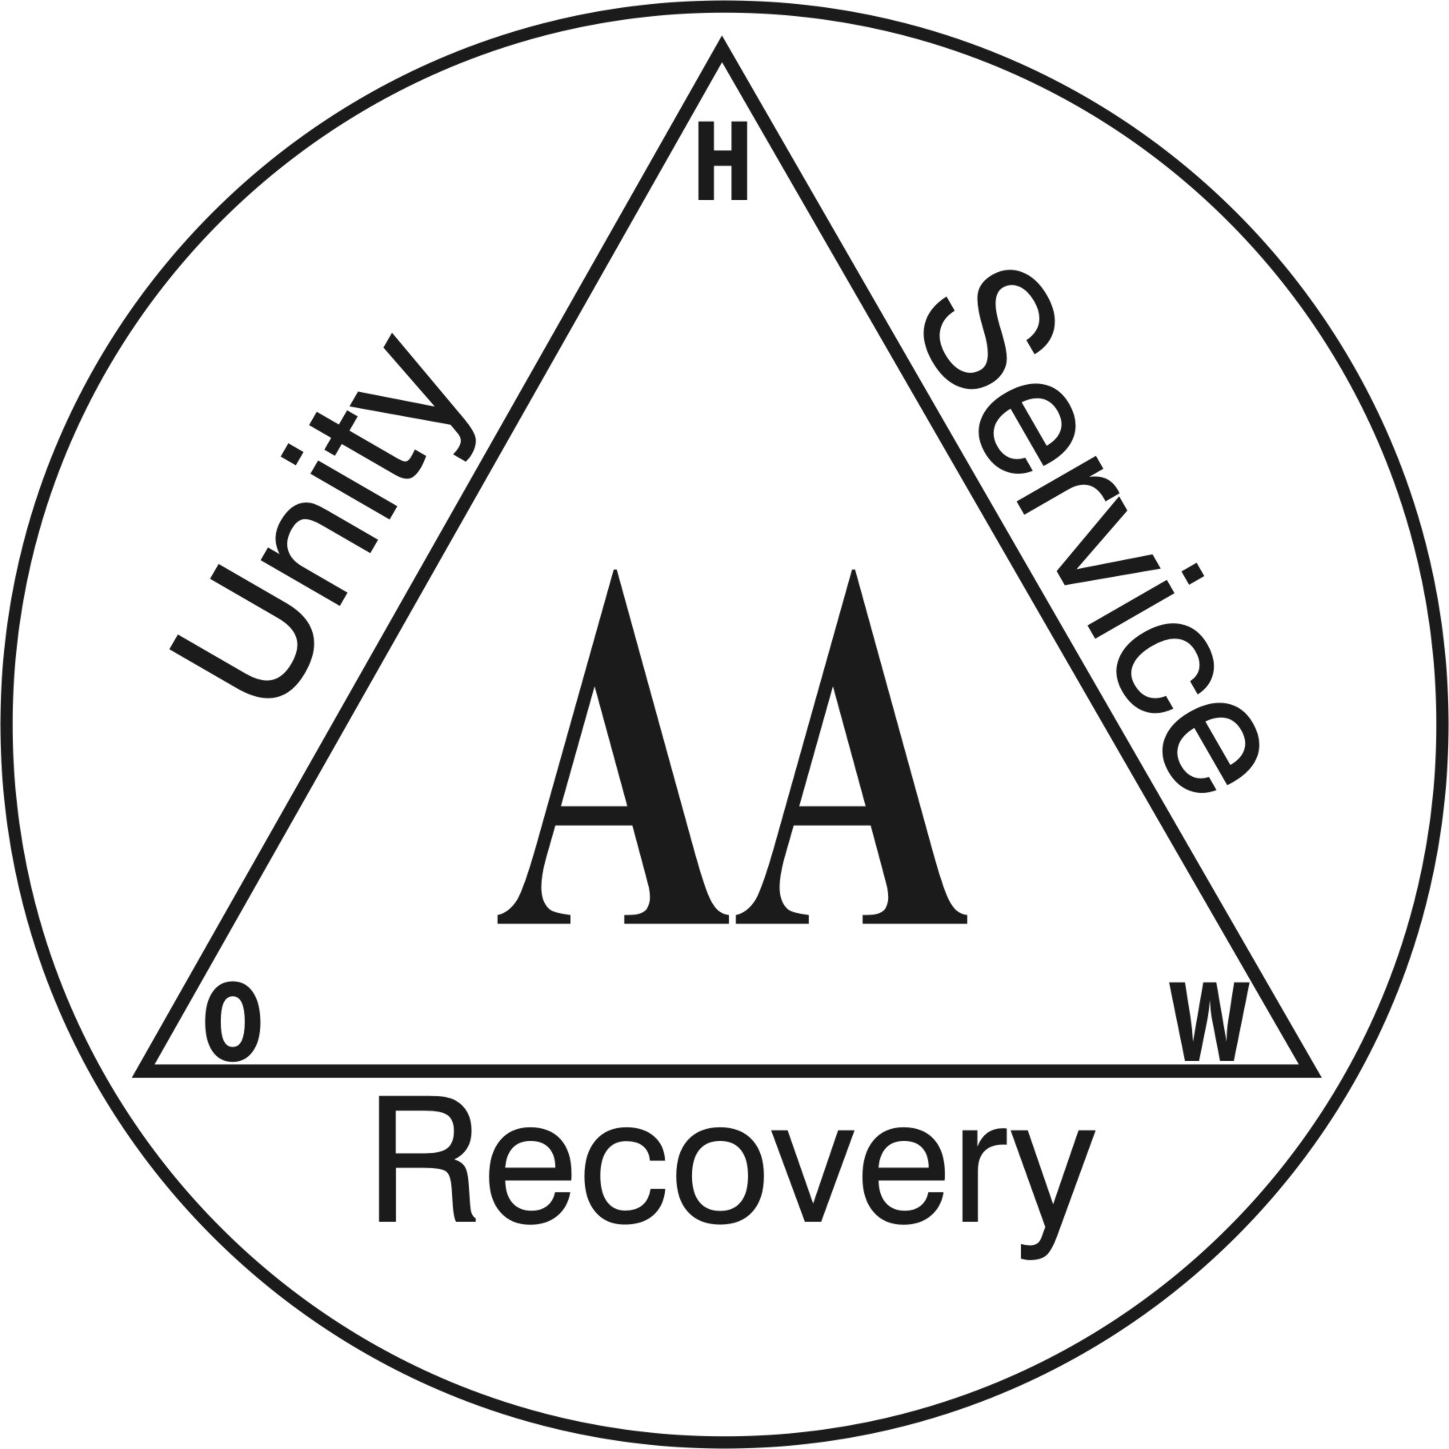
BACK TO BASICS – RE:WYND GROUP
1st.YEAR ANNIVERSARY
OPEN MEETING

TUESDAY 9th JULY 2019
6 pm – 7.30 pm
1. CHAIRPERSON
2. A.A SPEAKERS
COME ALONG AND HELP US TO
CELEBRATE BRING A FRIEND
THOMAS HERD HOUSE
10- 12 WARD ROAD DUNDEE
CONTACT: GEORGE 07761104612
EILEEN 07778604313

