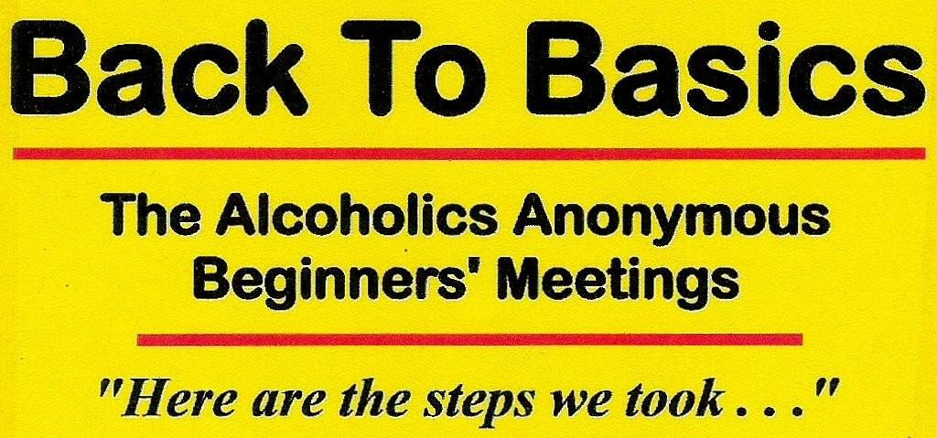

Back to Basics - Wally .P. in Oshawa
( Wally P – AA Archivist and Author of Back to Basics)

Date & Time: Tuesday November 9; 7pm -9pm

Location: Zion Christian Reformed Church
409 Adelaide Ave. East (at Central Park)
OSHAWA, ON

Contact persons:
Loraine M. 905 434 2814
Penny Claire T. 905 436 9057
Barry B. 905 720 1966

Topic: ‘AA in the 1940s – Why it worked’

