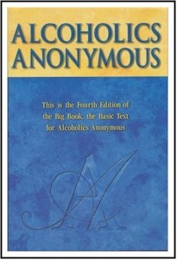
Let’s get ….

BACK TO THE
BASICS
….of sponsorship

With Wally P. (Tucson, AZ) A.A. Archivist and Historian

Monday, November 10, 2008
7:30-9:30 pm
Power Point Presentation on Sponsorship in the 1940’s
Niagara Orchard Community Church
5720 Dorchester Rd. (at High St.)

Niagara Falls, Ontario, Canada L2G-5S3
Directions from either North or South: Take the QEW. Take Hwy 20 exit (Exit 30)
Toward Dorchester Road. Take Frederica St. ramp. Turn Right onto Frederica St.
Turn Left onto Dorchester Rd. (RR-104)

Admission 7th Tradition

If you have any questions, please contact George D. at
905-988-7172

