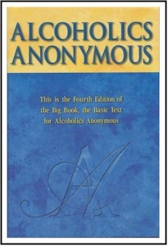
Let’s get ….

BACK TO THE

BASICS

…. of Sponsorship

With Wally P. (Tucson, AZ) A.A. Archivist and Historian
(Caretaker of the Dr. Bob and Anne Smith Archives)

Wednesday, August 4, 2010

During this insightful and informative PowerPoint presentation, Wally P. will demonstrate, using the “Big Book” of Alcoholics Anonymous, how to sponsor a newcomer through the Twelve Steps in three to four hours as Dr. Bob and the A.A. pioneers did during the 1940’s. This is an event for sponsors, sponsees, and those interested in learning more about the simple and straightforward process that was used during A.A.’s early days.
Hosted by the Serenity Twilight Retreat

Mount Saint Francis Retreat Center
41160 Retreat Road
Cochrane, Alberta, CANADA T4C-1A6

Meet and Greet: 5:30 pm
Dinner: 6:30 pm
Presentation: 7:30-9:00 pm

Cost: $35.00 per person

For more information, please contact:
Ian M.: 403-589-3237,
Chuck C.: 403-640-5353, or
David at the Retreat Center: 403-932-2012

