Back to Basics Seminar
33926 Calle La Primavera, Dana Point, CA 92629-2018

Saturday Morning: 9:00 am - 10:30 am    Overview of the Recovery Process    Beginners' Meeting - Session 1~~Steps 1, 2 & 3  Saturday Morning: 10:30 am - 11:00 am    Break  Saturday Morning: 11:00 am - 12:00 noon    Beginners' Meeting - Session 2~~Steps 4 & 5  Saturday Afternoon: 12:00 noon - 2:00 pm    Lunch Break (Food Provided by Host Committee)    5th Step with Sponsor or Sharing Partner | Saturday Afternoon: 2:00 pm - 3:00 pm    Beginners' Meeting - Session 3 ~~Steps 6, 7, 8 & 9  Saturday Afternoon: 3:00 pm - 3:30 pm    Break (Practice Eleventh Step / Write Guidance)  Saturday Afternoon: 3:30 pm - 4:30 pm    Beginners' Meeting - Session 4~~Steps 10, 11 & 12

Location

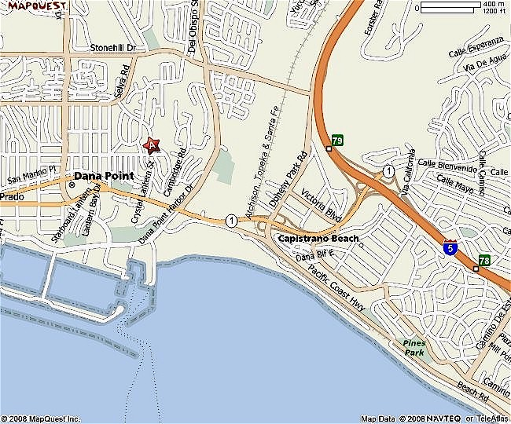

Directions

From the NORTH  Take I-5 SOUTH.  Merge onto CA-1 via EXIT 79 toward PACIFIC COAST HWY.  After 1.5 miles, turn RIGHT onto CRYSTAL LANTERN ST.  After 0.1 miles, turn RIGHT onto MANZANITA DR.  After 0.1 miles, turn LEFT onto CALLE LA PRIMAVERA.  After 0.3 miles, END at 33926 CALLE LA PRIMAVERA, DANA POINT, CA 92629-2018 | From the SOUTH  Take I-5 NORTH.  Merge onto CA-1 via EXIT 79 toward BEACH CITIES.  After 1.8 miles, turn RIGHT onto CRYSTAL LANTERN ST.  After 0.1 miles, turn RIGHT onto MANZANITA DR.  After 0.1 miles, turn LEFT onto CALLE LA PRIMAVERA.  After 0.3 miles, END at 33926 CALLE LA PRIMAVERA, DANA POINT, CA 92629-2018

