Back to Basics
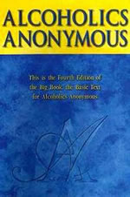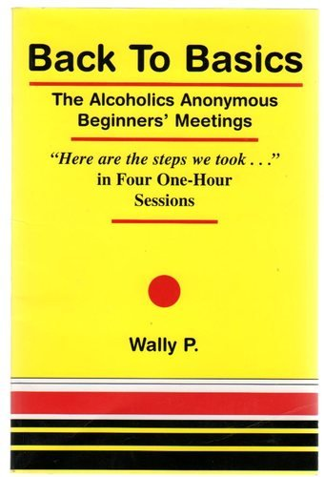
____________ ____________
The Alcoholics Anonymous Beginners’ Meetings
_______ ________________
“Here are the steps we took…”
in Four One-Hour Sessions - Wally P.

Discover the sheer simplicity of the early AA program that produced a very high recovery rate from alcoholism. Experience the spiritual awakening that occurs when you take the Twelve Steps in four one-hour sessions.
Saturday, January 7th 14th 21st 28th
9:00 AM - 10:00 AM
Fellowship Hall - Palm Desert
Contact: June T. (760) 880-0009
This is a four week commitment.
Working all twelve steps with your sponsor or sharing partner
Bring Your Big Book – No Charge

