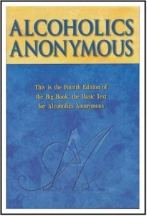
Let’s get ….

BACK TO THE

BASICS

…. of the Big Book

History Presentations, All Twelve Steps in One Day and an Eleventh Step Guidance Meeting

With Wally P. (Tucson, AZ) A.A. Archivist and Historian

Friday, Saturday and Sunday, October 9, 10 & 11, 2015

(The agenda is on the reverse side of this flyer)

Northbound’s Behr Center
1040 W. 17th Street
Costa Mesa, CA 92627
(Directions on reverse side)

This is a seminar for “anyone or everyone interested in a spiritual way of life.” Learn the history and evolution of these important action steps and how they were implemented during the early days of the Twelve-Step movement.

There are no fees for the presentations as we will be observing the Seventh Tradition to cover the cost of lunch and handouts.

---------------------------------------------------------------------------------------------------

RSVP to Karen.happel@livingsober.com so the facility is aware of how many handouts and lunches are necessary for the attendees.

