Back to Basics Seminar
9610 E Cactus Road, Scottsdale, AZ 85260-5102

Saturday Morning: 9:00 am - 10:30 am    Overview of the Recovery Process    Beginners' Meeting - Session 1~~Steps 1, 2 & 3  Saturday Morning: 10:30 am - 11:00 am    Break  Saturday Morning: 11:00 am - 12:00 noon    Beginners' Meeting - Session 2~~Steps 4 & 5  Saturday Afternoon: 12:00 noon - 2:00 pm    Lunch Break (Food Provided by Host Committee)    5th Step with Sponsor or Sharing Partner | Saturday Afternoon: 2:00 pm - 3:00 pm    Beginners' Meeting - Session 3 ~~Steps 6, 7, 8 & 9  Saturday Afternoon: 3:00 pm - 3:30 pm    Break (Practice Eleventh Step / Write Guidance)  Saturday Afternoon: 3:30 pm - 4:30 pm    Beginners' Meeting - Session 4~~Steps 10, 11 & 12

Directions
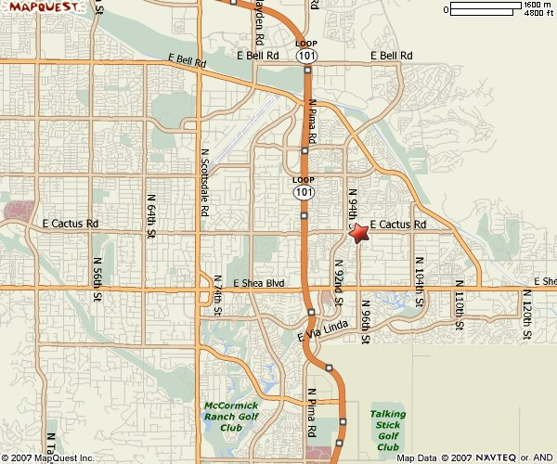

From the South  Take I-10 W toward PHOENIX.  Take EXIT 161 toward PECOS RD / AZ-202-LOOP E.  After 0.1 miles, take the AZ-202-LOOP E exit.  After 0.7 miles, merge onto AZ-202 LOOP E.  After 3.2 miles, take the AZ-101-LOOP exit- EXIT 50A.  After 0.9 miles, merge onto AZ-101 LOOP N.  After 20.8 miles, take the CACTUS RD exit- EXIT 40.  After 0.3 miles, turn SLIGHT RIGHT onto E CACTUS RD.  After 0.9 miles, end at 9610 E Cactus Rd, Scottsdale, AZ 85260-5120. | From the North  Take I-17 S toward PHOENIX  Take the AZ-101-LOOP E exit- EXIT 214C.  After 1.0 miles, merge onto AZ-101 LOOP E.  After 16.0 miles, take the CACTUS RD exit- EXIT 40.  After 0.3 miles, Turn LEFT onto E CACTUS RD.  After 1.0 miles, end at 9610 E Cactus Rd, Scottsdale, AZ 85260-5120. | From the West  Take I-10 E toward PHOENIX.  Take the AZ-202-LOOP E exit- EXIT 147A.  After 0.6 miles, merge onto AZ-202 LOOP E.  After 8.8 miles, take the AZ-101-LOOP N exit- EXIT 9.  After 1.3 miles, merge onto AZ-101 LOOP N.  After 10.7 miles, take the CACTUS RD exit- EXIT 40.  After 0.3 miles, turn SLIGHT RIGHT onto E CACTUS RD.  After 0.9 miles, end at 9610 E Cactus Rd, Scottsdale, AZ 85260-5120

