FREE “Big Book”
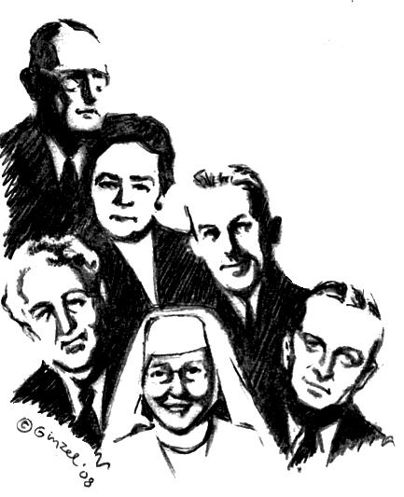
Twelve Step Workshop
We will be taking all Twelve Steps following the Spiritual directions from the Big Book.
Presented by: Katherine G. & Brian T
“A design for living the 12 Steps”
Saturday May 3rd 08
From 9:00am-4:00pm

Women in New recovery
860 N. Center St. Mesa, AZ 85201

Bring your Big Book, bring a Pen, bring a Highlighter, bring a Friend. Bring someone to share with, for the day or we will provide you with someone. Do you want to be happy, joyous, and free now or later? Get “unstuck” on your steps ~ 4th step work-sheets & expand your spiritual program on the 11th Step two-way communication with God that Dr. Bob and early A.A.’s used.

9:00AM – 10:30 AM  Introductions and   Session # 1 Surrender ~Steps 1, 2 , 3  (Break) 10:30am-10:45am  10:45AM - 12:00 PM   Session # 2 Sharing ~Steps 4 and 5.  Fourth Step will be written out during meeting | ● (Lunch Break 1 hr) 12:00PM- 1:00PM  do 5th Step with Sponsor or Sharing Partners  Lunch provided  1:00PM - 2:15PM   Session # 3 Restitution ~Steps 6, 7, 8 ,9 +10  (Break) 2:15-2:30PM  2:30PM - 3:45PM   Session # 4 Guidance ~Steps 11 + 12

Contact: Shay 480-217-3572
845-750-7762
e-mail WINR.SHAY@YAHOO.COM

