VERDE VALLEY “BIG BOOK EXPERIENCE”
A.A. UNITY DAY 2012
(Tradition 1: Personal recovery depends upon A.A. unity.)
Presented & Hosted by “Tuesday Night Big Book Experience A.A. Group”
*Ever get a case of the R.I.D.S.? (Restless, Irritable and discontent)
*Ever think “Nothing is wrong, but something is just not right?”
*Ever hit a “Wall” in sobriety?
*Ever think “Is this all there is? _______________________________________________________________________
GOOD NEWS!! THERE IS A SOLUTION AND IT’S IN THE BIG BOOK!! 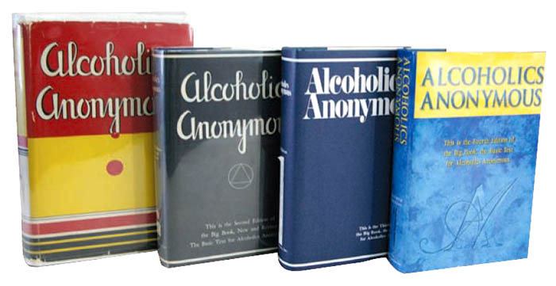“That evening Bob and I told them that we were within sight of success and that we thought this thing might go on and on and on, that
a new light indeed was shining in our dark world. But how could this light be reflected
and transmitted without being distorted and garbled?”
(AA History and How the Big Book was put together) a talk by Bill Wilson Ft. Worth, TX 1954
WHEN: Saturday FEBRUARY 25th 2012 8:00am-5:00pm
WHERE: Immaculate Conception Church. 700 n. Bill Gray rd.
corner of 89A and Bill Gray Rd. Just north of Cornville rd on 89A.
WHO: 8 AA members from 7 different towns:
(Sedona, VOC, Cottonwood, Cornville, Clarkdale, Rimrock, and Camp Verde.)
Share their experiences with using this Book.
This workshop is FREE, FREE, FREE!
Lunch is on your own.
Time schedule of steps available at registration table.

