FREE “Big Book”
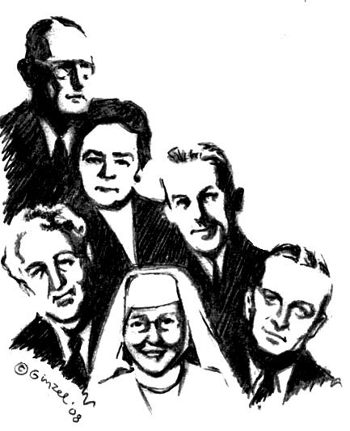
Twelve Step Workshop
We will be taking all Twelve Steps following the Spiritual directions from the Big Book.
Sponsored and hosted by District 09-904
“A design for living the 12 Steps”
Sunday 9:00am-5:00pm

May 11th 08
Mehovey County Library
1770 McCulloch Blvd.
Lake Havasu City, AZ
(in the K-mart parking lot)
Bring your Big Book, bring a Pen, bring a Highlighter, bring a Friend. Bring someone to share with, for the day or we will provide you with someone. Do you want to be happy, joyous, and free now or later? Get “unstuck” on your steps ~ 4th step work-sheets & expand your spiritual program on the 11th Step two-way communication with God that Dr. Bob and early A.A.’s used.

9:00AM – 9:45 AM  AA History & sponsorship presentation.  A.A. Archives will be displayed all day.  (Break) 9:45am-10:00am  10:00AM-11:15AM   Session # 1 Surrender ~Steps 1, 2 , 3  (Break 11:15AM-11:30AM  11:30AM - 12:45 PM   Session # 2 Sharing ~Steps 4 and 5.  Fourth Step will be written out during meeting | ● 12:45PM- 2:00PM  ( LUNCH BREAK 1hr 15 minutes)  do 5th Step with Sponsor or Sharing Partners  Lunch provided  2:00PM-3:15PM   Session # 3 Restitution ~Steps 6, 7, 8 ,9 +10  (Break) 3:15PM-3:30PM  3:30PM - 4:45PM   Session # 4 Guidance ~Steps 11 + 12  Anne Smith archives presentation on 11th Step.

Contact: Skip 928 486- 3992 Moore.skip@gmail.com

