Start your new years out right by taking all 12 Steps!
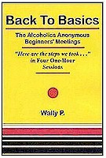
Back to Basics
Alcoholics Anonymous Beginner’s Meeting
Here are the Steps We Took
4 One Hour Workshops
Take all 12 Steps using the simple method which Dr. Bob used in the
1940’s to introduce newcomers to the A.A. program; a time when recovery was at 50 – 75%.
January, 4th 8-9:15PM Overview & Step 1
January, 11th 8-9:15PM Steps 2, 3, 4
January, 18th 8-9:15PM Steps 5, 6, 7, 8, 9
January, 25th 8-9:15PM Steps 10, 11, 12
Where? Mercy Hospital Recovery Center 40 Park Road Westbrook, ME
For Information call Lisa 857-8041

