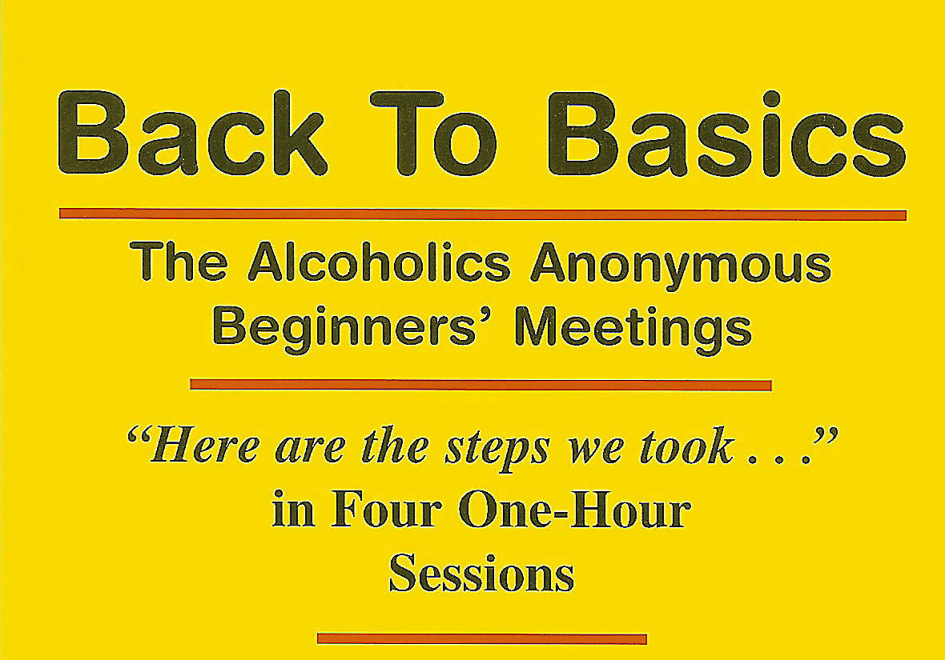

Announcing a New Meeting

Where: 605 n 65TH Ave. (Corner of 65th & Jackson)

When: SATURDAY AFTERNOONS starting Sept 3, 2011

(Starts promptly @ 2:00 Pm)

Who: Newcomers or anyone who wants to complete the 12 Steps in 4 1 hour weekly sessions.

How: Bring your sponsor or a sharing partner to work with you and your BIG BOOK.

